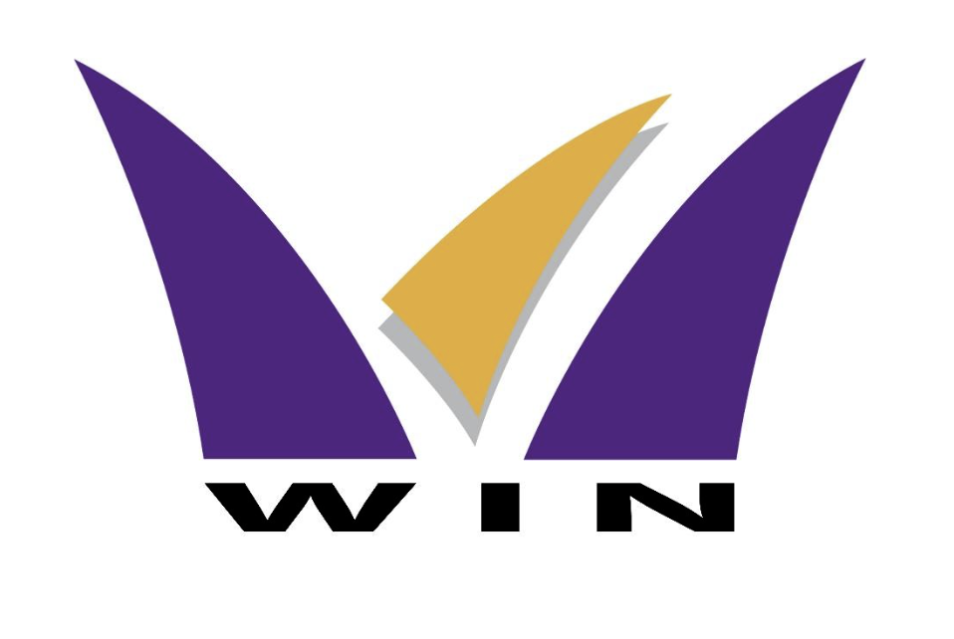

Wentworth Institute of Higher Education (WIN)

MIT122 – Interactive Web Design and Development

Assignment 2

Group Project

Group Members:

Tshering Yangzom (987470)

Thinley Phuntsho (987458)

Tenzin Wangmo (987478)

Hennah Rai (987499)

Tutor: Ethan Phang

October 7, 2024

TABLE OF CONTENTS

**1. Introduction 2**

**2. Problem and Challenges Identified 2**

2.1 Manual Processes Leading to Delays 2

2.2 Systems worked Manually 2

2.3 Closeness Employers 3

2.4 Inefficient Performance Management 3

**3. Project Objectives 3**

3.1. Enhancing Employee Relation through Streamline Employee Leave Application Process. 3

3.2 Take Data, Specifically Employee Data, Out Of The Individual Employees’ Hands 3

3.3 Increasing the Robustness of Performance Evaluation System 3

3.4 Exclusive and Access Control by Roles 4

3.5 Improve on the Accountability for Information Compile and Processing 4

**4. Technologies Used 4**

4.1 PHP (Server Side Scripting Language). 4

4.2 MySQL Relational Database Management System 4

4.3 HTML5 (Content Structuring) 4

4.4. CSS3 (Styling and Responsive Design) 4

4.5. JavaScript (Client-Side Interactivity). 5

**5. System Features 5**

5.1 Role-Based Dashboards 5

5.2 Employee Profile Management 7

5.4 Leave Management 8

5.5. . Performance Management 9

5.6. Contacting the Administrator 9

**6. Methodology: SCRUM 10**

6.1 Sprint Planning 10

6.2 Daily Stand-Ups 11

6.3 Sprint Reviews 11

6.4 Sprint Retrospectives 11

**7. Database Structure 11**

7.1 Employees Table 11

7.2 Leave Applications Table 11

7.3 Performance Ratings Table 11

7.4 Targets Table 12

**8. Conclusion 12**

# **1. Introduction**

Human resources are in great demand in the contemporary world because the proper management of personnel ensures a company’s success. To the many operating businesses, especially those in Thimphu – Bhutan, the stymied systems of employing papers to manage their employees have been outdated. Such outdated practices include record keeping, leave applications as well as performance evaluations and are characterized by inaccuracy and time consumption.

The inefficiencies include leave management, performance tracking of employees, and general record keeping While the EMS is developed as a web-based platform to easily address these inefficiencies. The system also helps minimize the overall time and commitment required by the management on the various aspects of employees as most of it is available online with real-time and instant access for the employees as well as administrators.

The EMS incorporates contemporary web technologies including PHP as a server-side scripting tool, MySQL used as database back end, and HTML5 and CSS3 for the site layout and interactivity and JavaScript for interactivity. The integration of these technologies also guarantees that the system is highly flexible, secure and performs optimally across devices including smart phones, tablets and PCs.

Since it provides different features for the employees and administrators, both sets of users can manage to complete their activities effectively. While using Toast, employees can submit leave requests, check the status of requested leave and view the performance ratings while on the other hand administrators have full control over employee information, performance appraisals and leave management. This RBAC makes it easier to avoid a situation where one or several user accounts have access to multiple functionalities within a system.

# **2. Problem and Challenges Identified**

# 

## 2.1 Manual Processes Leading to Delays

It has been observed that many applications and documents such as leave application or performance evaluation passes through several stages of approval and update manually on papers. These delays are particularly detrimental in companies with massive employees since the HR sections spend most of their time trying to manage piles of paperwork.

## 2.2 Systems worked Manually

For this reason, there are many chances of having errors in data input and data repetitiveness, misplacing important documents, and maintaining discordant records. There are high chances that employees may lose the forms and thereby be given leaves multiple times, or that performance appraisals may be incorrectly filled, which results in conflicts or discontent among the employees.

## 2.3 Closeness Employers

Provide the employee with no way to monitor the status of a leave application or performance rating in real time. This lack of visibility leads to confusion and in most cases employees need to chase their respective HR departments further enriching the issue with the admin burden.

## 2.4 Inefficient Performance Management

It typically takes a long time to complete performance reviews in an archaic system and the data collected may only be partial, affording decision makers a biased outlook into promotions and bonuses. Since there is no definite pattern for the assessment of their performance in relation to set objectives, the directors fail to offer proper feedback.

All these challenges were noticed in different organizations, much as in the discussions with the respondents of this study recruited from different Bhutanese firms. These problems have now been solved through utilizing EMS which stands for Employee Management System through automation, computerized record and real time access.

# **3. Project Objectives**

The main goal is to establish a user-friendly and useful tool – the EMS, which has to facilitate routine processes connected with employees and enhance an admission of their results by administrators. The following goals are critical to the system’s success:

## 3.1. Enhancing Employee Relation through Streamline Employee Leave Application Process.

The EMS enables the submission of leave applications by filling of a form as shown in the next section. The web application user will be notified to administrators of the new applications which the administrator will either accept or reject. The timely monitoring of leave applications means that the employees receive a notification regarding the status of their applications anytime.

## 3.2 Take Data, Specifically Employee Data, Out of The Individual Employees’ Hands

Employee information concerning their records is well-organized through a centralized MySQL database since it is easier to record, update and modify the records of the employees. The registered administrators can create new records of the employees, update certain fields, and remove unnecessary information using the Web interface.

## 3.3 Increasing the Robustness of Performance Evaluation System

The EMS incorporates a tool for establishing performance targets and looking at performance appraisals. The system allows the employees to see their performance appraisals in realtime and the administrators can feedback to them via the stated system. This gets rid of the time and mistake spending related to conducting performance management on paper.

## 3.4 Exclusive and Access Control by Roles

RBAC is used throughout the system, which means that for example employees and administrators will have only the features that are related to their job. While the employee self service allows an employee to approve his/her own leave request and performance review, the human capital management provides the administrators with general oversight of the employee records and leave approval.

## 3.5 Improve on the Accountability for Information Compile and Processing

The changes are proposed to be implemented to make the programme more efficient and these include the use of a digital platform in place of a paper-based system because it reduces the chances of data entry error. It also enforces the issue of transparency whereby the employees will be provided with real time leave and performance tracking which saves them the trouble of having to repeatedly follow up their HR departments.

# **4. Technologies Used**

The EMS or the Employee Management System depends on contemporary web technologies which complement each other to create a strong and highly portable platform. Every technology has its purpose, making everything smooth and secure in the system they created.

## 4.1 PHP (Server-Side Scripting Language).

PHP is one of the most popular open-source scripting languages tailored for web applications development. In the EMS, PHP is applied for the server-side of request handling, form handling and most of the times database operations are done. It has significant function in managing the sessions for the user, user authorization, leave application and back up data from the database. Hence, since PHP can easily link with MySQL it is favourable to developing dynamic database-based applications.

## 

## 4.2 MySQL Relational Database Management System

MySQL is highly optimized and reliable relational DBMS that is used to store all data related to the employees and their leaves, performance reviews, and accounts credentials of users. MySQL in the EMS has a responsibility of maintaining data integrity, security, as well as efficiency in displaying information. This database is normalized for increasing data dependency of employees, leave application forms, and performance rating done on employees.

## 4.3 HTML5 (Content Structuring)

HTML5 extends support in structuring the EMS web pages, so generic content forms such as forms, tables and navigation widgets can be deployed in a comprehensively identifiable shape. Another advantage of using HTML5 is that new elements also make the web pages easier to read for the user and the search engine to understand the structure of the layout.

## 4.4. CSS3 (Styling and Responsive Design)

CSS3 is used to style the elements of HTML5 whereby creating web pages, more attractive and well structured. Most importantly it allows the use of modern techniques like the responsive layouts where the design can adjust to whichever the screen size is. This guarantees that the EMS is compatible with different devices ranging from desktop to smart phones. CSS3 also provides opportunities to style form elements, buttons and navigational menus.

## 

## **4.5. JavaScript (Client-Side Interactivity).**

JavaScript enhances the performance of the EMS by adding form validation and making dynamic data modifications. For instance, in the case of a leave application form, JavaScript will pre-validate all fields before accepting the application and field validation regarding dates. JavaScript also works in managing the areas such as sorting the records of the employees or giving feedback at the time of form submission without refreshing the whole page.

# 5. System Features

The Employee Management System (EMS) has several features of a complex for the purposes of solving numerous tasks of human resources departments, enhancement of the transparency of organizational processes, and optimalization of functioning within an organization.

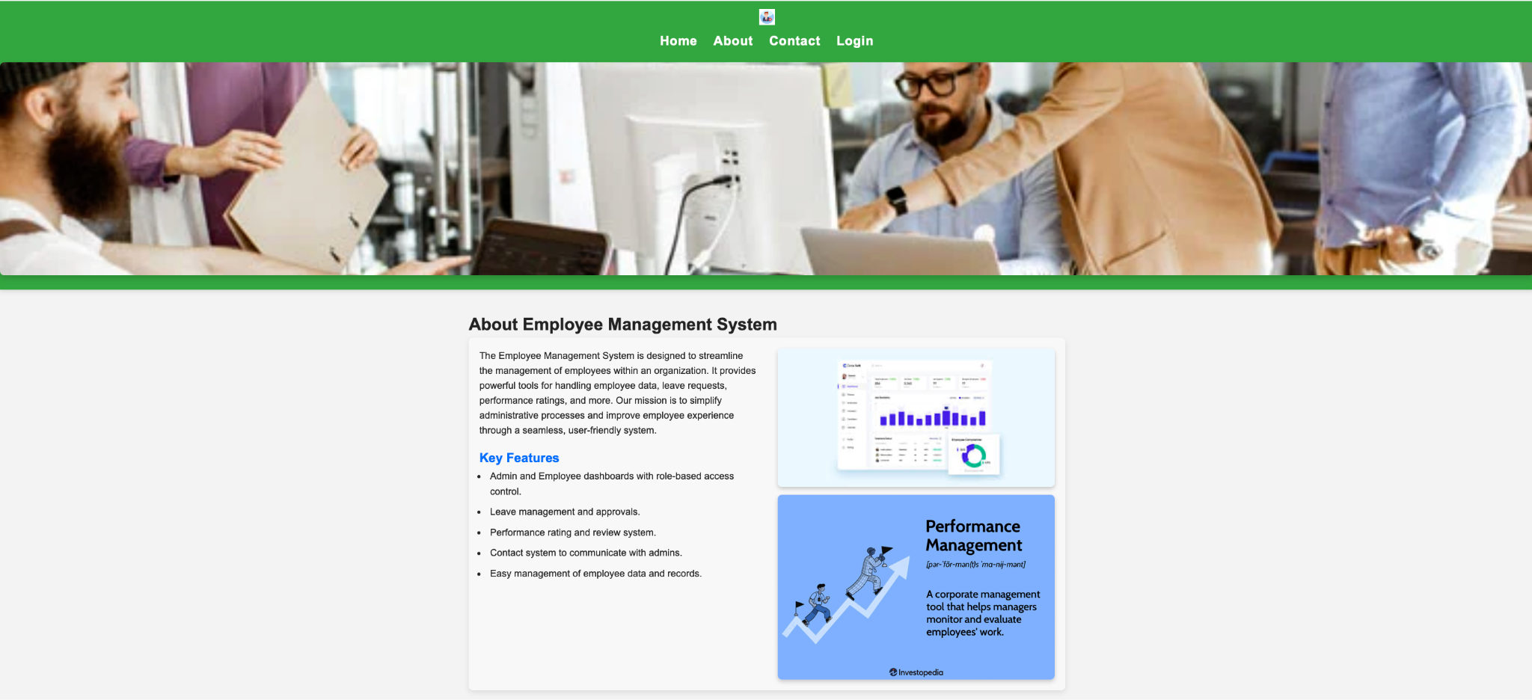

## 5.1 Role-Based Dashboards

Employee Dashboard: Employees are required to sign in with their username and password after which they are redirected to the employee’s dashboard containing information about past leave and performance appraisal, current leave balance and several others. By accessing this dashboard, employees may apply for leave, see the status of leave applications and view performance appraisals.

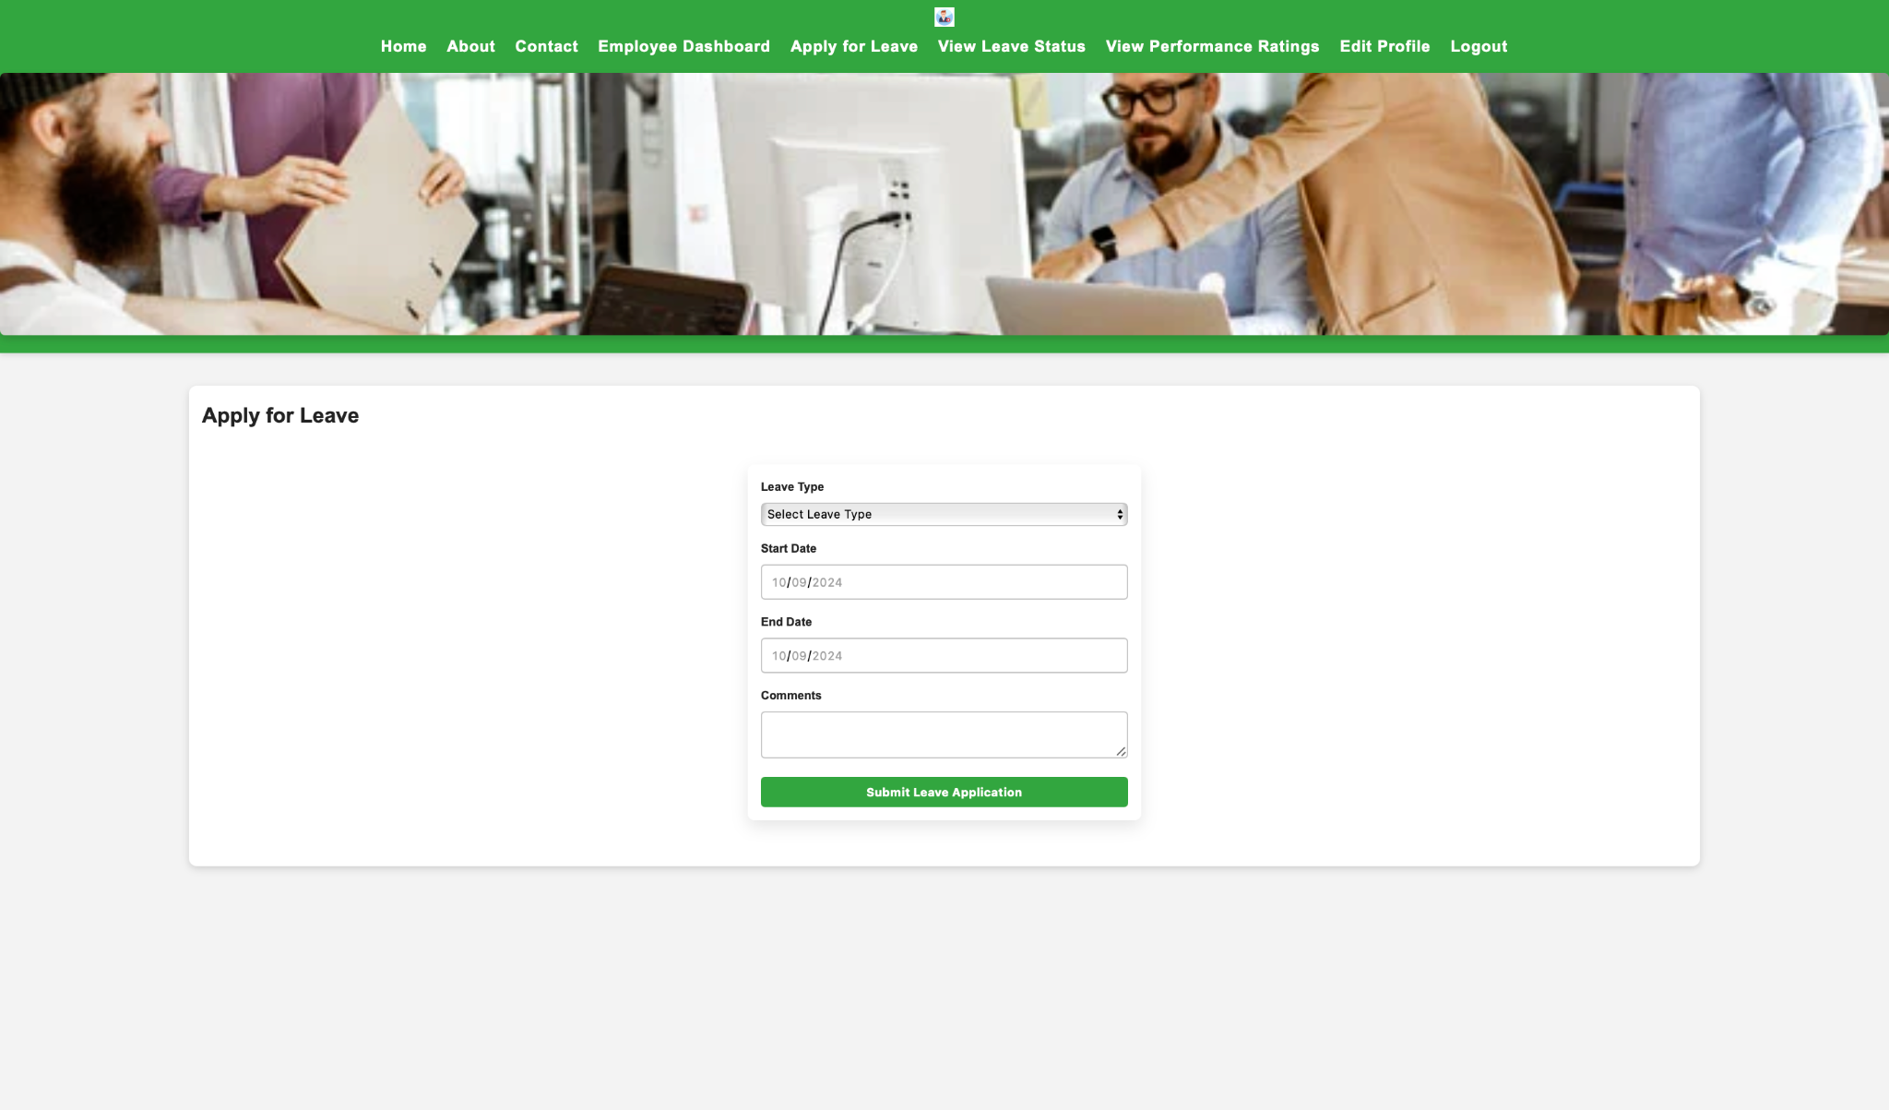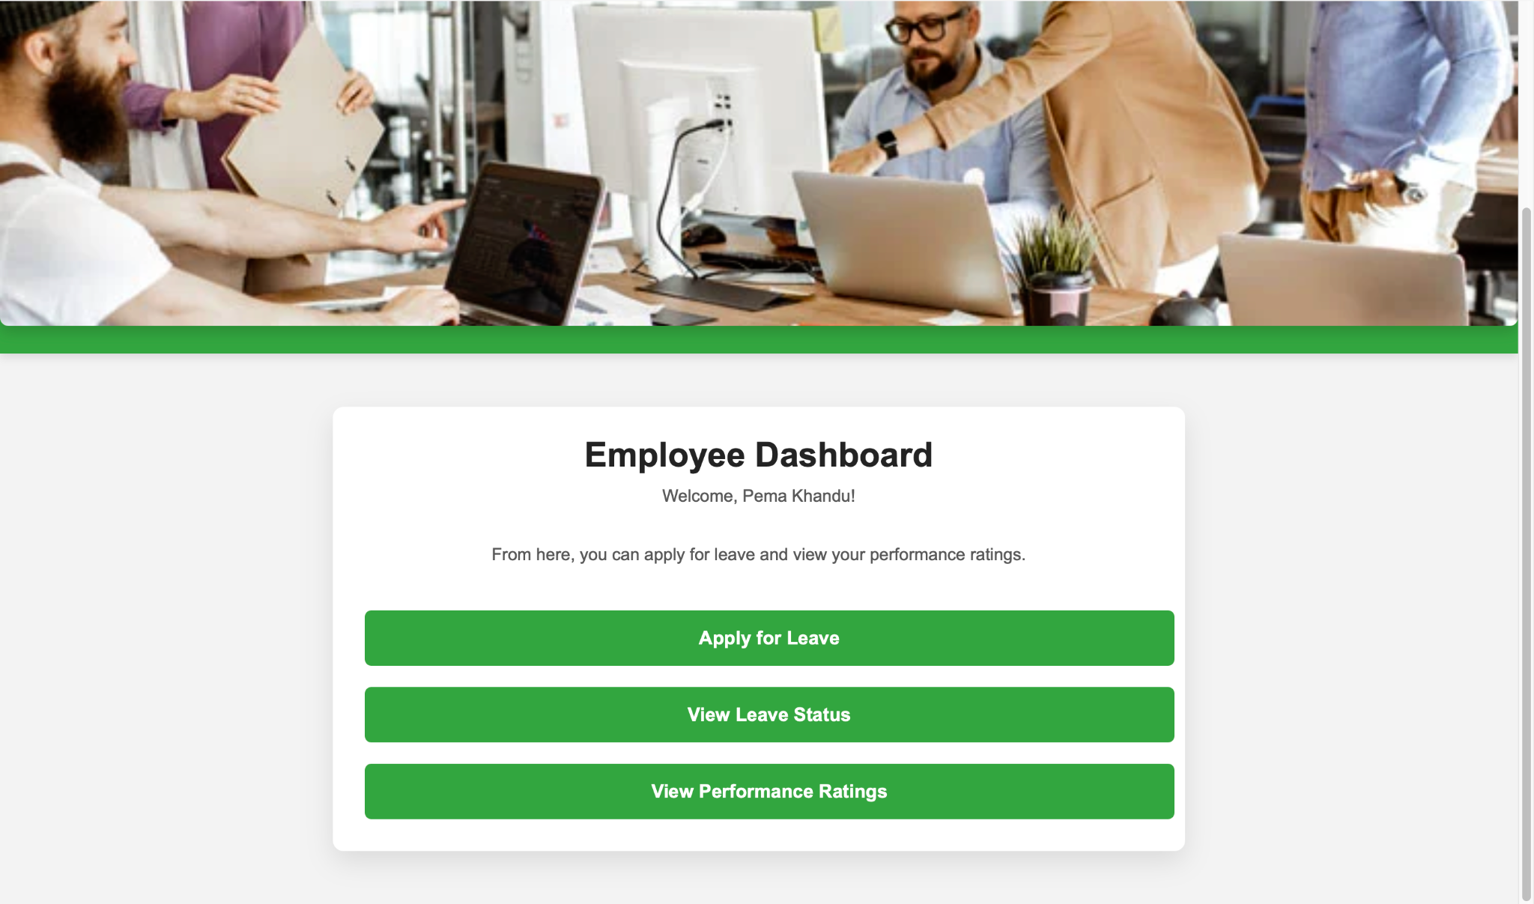

Administrator Dashboard: The employers have a more developed interface allowing them to modify the records of the subordinates, approve or refuse the requests for leave, or give an estimation of the results achieved. Now, the administrators also can input or modify the employee information and can even delete this information if needed.

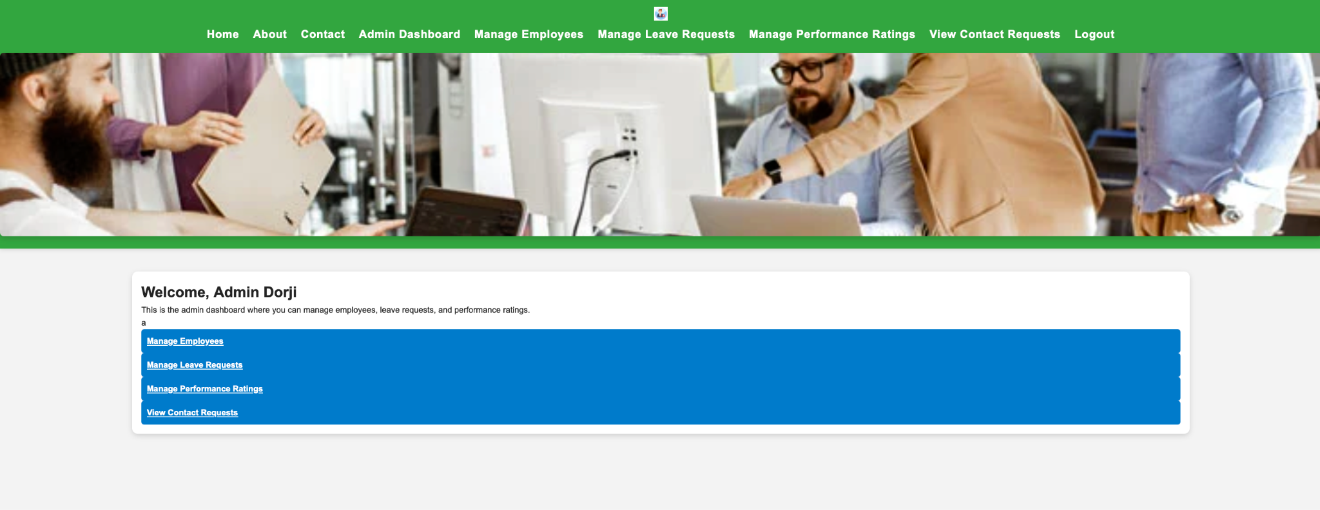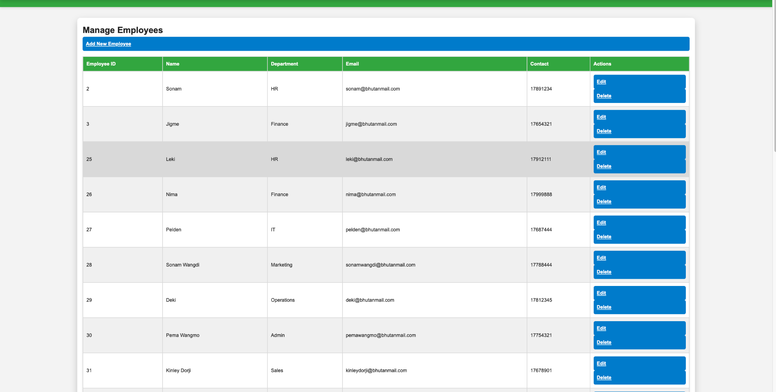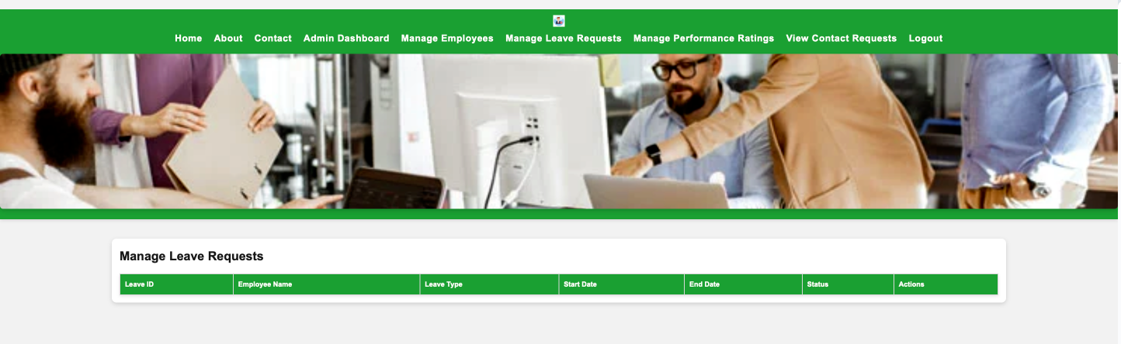

## 5.2 Employee Profile Management

Every employee has his or her own personal page where he or she can see own, and change data like email, phone number and department. This makes sure that lots of employee records are current and changes do not have to be done extensively by the administrators.

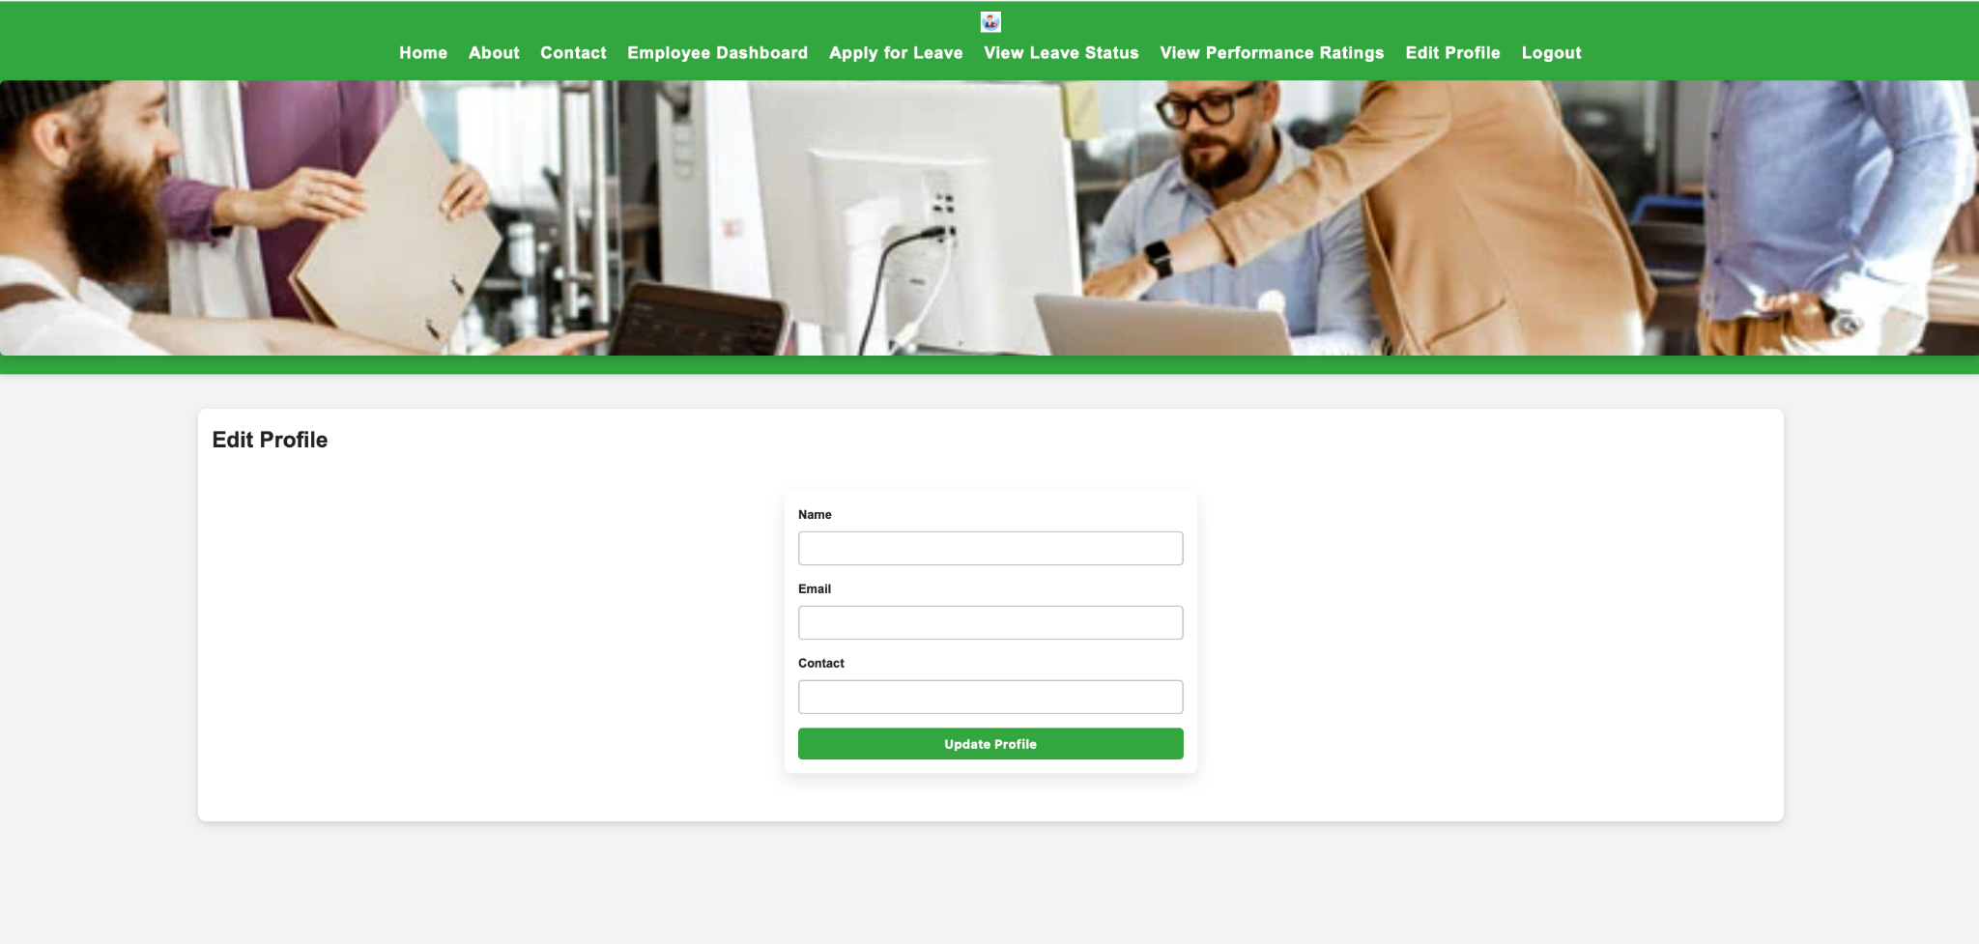

## 5.4 Leave Management

There leaves form available where employees can enter their leave details such as the type of leave, date from, date till and if any special comments they wish to make. The system checks data for integrity so that the leave dates are reasonable according to the given request. Once submitted the administrators get a notice of the new application and they can accept or deny it from the admin control panel.

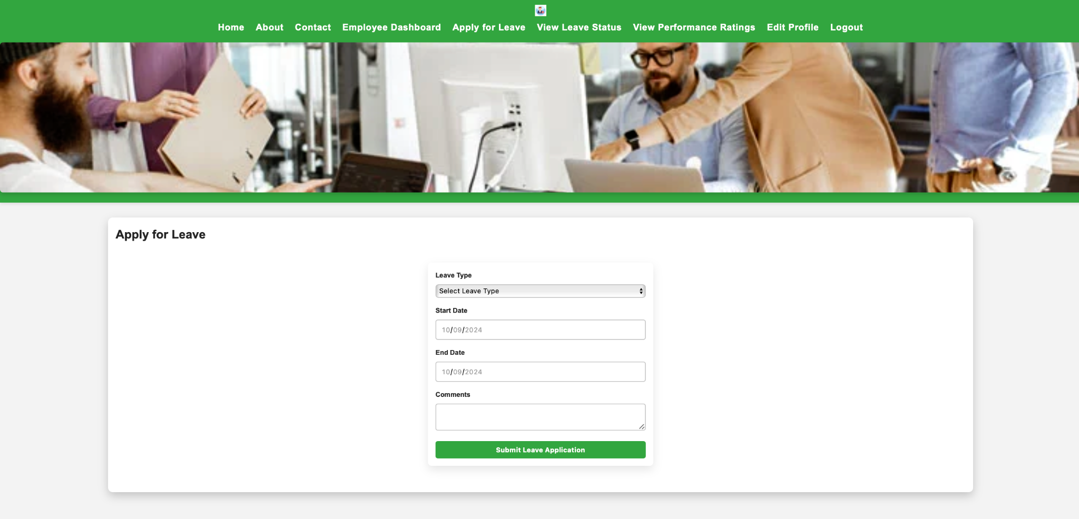

Allowing employees to check the status of their leave (pending, approved or rejected) at real-time. This feature complements the work of having to physically chase HR staff to follow up on their leave by making the process less cumbersome than before.

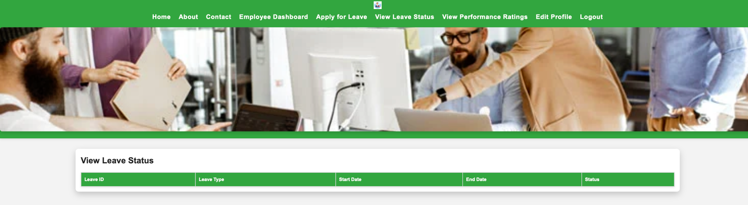

## 

## 5.5. . Performance Management

Employee Performance Ratings:

Finally, at the end of the evaluation period, the administrators use the assessment of the accomplishment of the performance targets to arrive at the performance ratings. The Performance Ratings are captured under the Performance Rating table and are available in the dashboard. Said administrators can also post comments or notes to provide employees with insights concerning their performance and points of inefficiency.

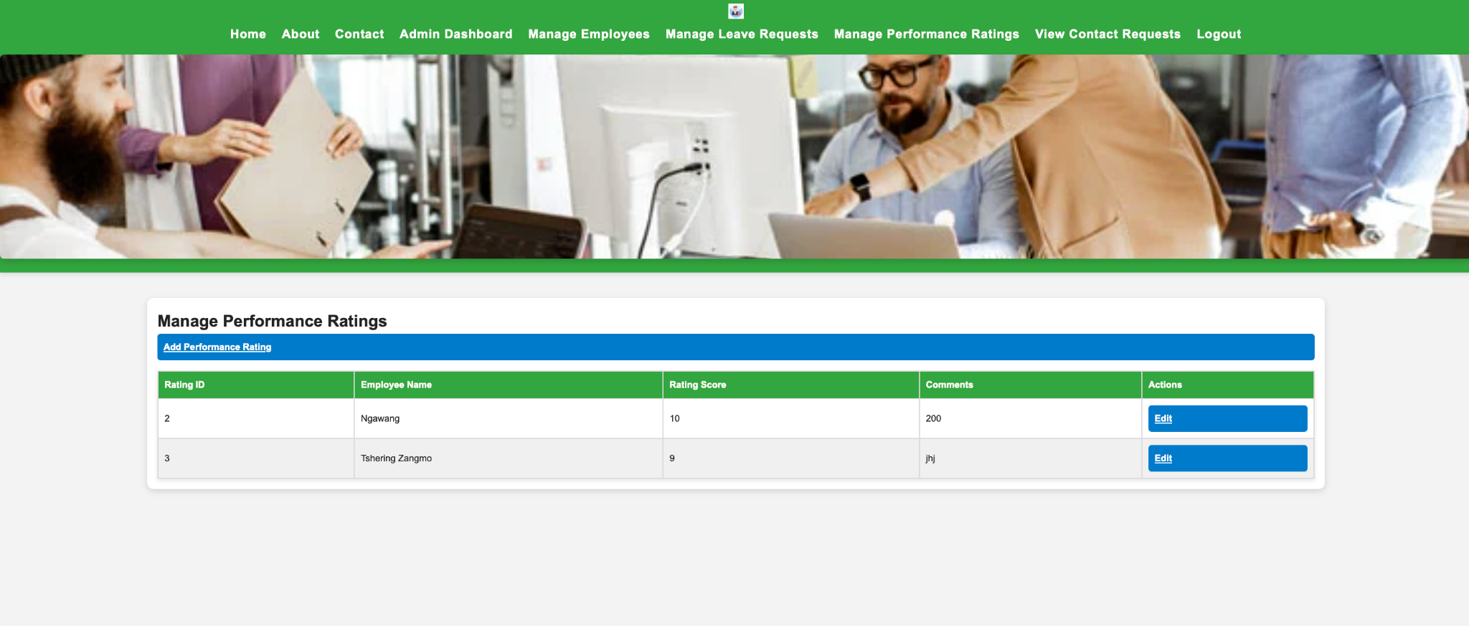

Employee View of Performance Ratings:

Individuals who have been appraised can log in to see their scores and comments made by the appraiser so that they may get a perception of what the latter has seen and can appreciated. This feature enables organization leaders to make performance appraisals credible and transparent to the employees.

## 5.6. Contacting the Administrator

The Contact Us feature is employed to enable employees submit their message directly to the administrator if they need any assistance or information. This feature makes certain these employees get to talk to HR pr the administration team directly.

Employee Contact Form:

It allows employees to send messages through use of the contact form to incorporate issues as to do with leave status, performance evaluation or bother issues falling under the human resource department. This form collects the employee’s name and email address and the message the employee wants to share.

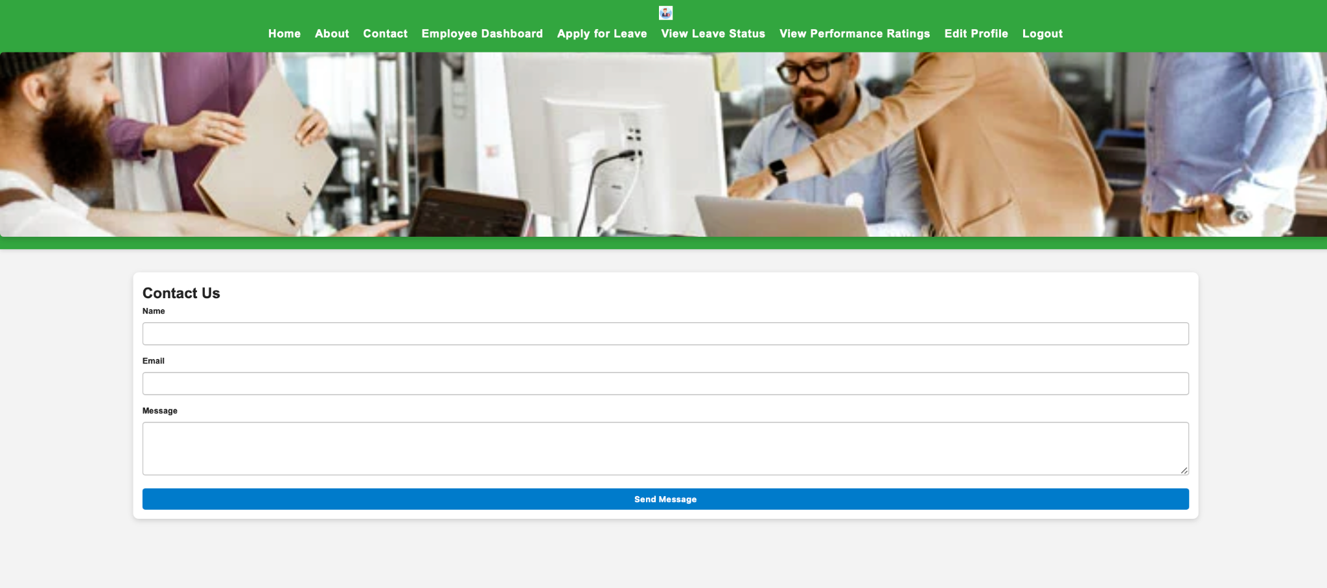

Admin View of Contact Messages:

The contact messages which employees send can be viewed and admin istered by the administrators. They can also filter messages as reviewed or pending in order to make sure that all the messages have been dealt with appropriately from the admin dashboard. This feature enhances interaction between workers and employing entities in order to gain a defined better working relationship as well as support connection.

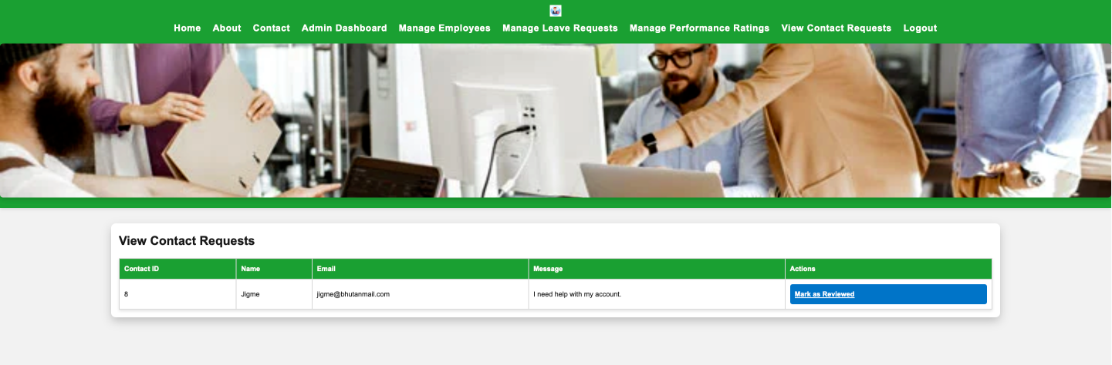

# **6. Methodology: SCRUM**

The development the Software has been done using SCRUM, an agile methodology which aims at achieving iterative and incremental development combined with frequent evaluation. SCRUM was selected because this model can easily respond to changing requirements and stakeholders’ feedback at the stages of a project implementation.

## 6.1 Sprint Planning

Amid the project, it was divided into several sprints, where each sprint tackled took 2 weeks to complete. Thus, during the initial planning for the sprint, the team opted for the specific features that would be crucial to employees, starting with the authorization process, the system for application for leave, and performance reviews before flowing to other improvements for the system. The goals set were sprint based and ensured that the entire team was able to stay focused on the development of functional features at the end of each sprint.

## 6.2 Daily Stand-Ups

This business used daily stand-up meetings to make sure its development team stayed on course in case of any problems. The organisation in these short meetings ensured that the team members were able to discuss and plan their advancement, to express pre-empted hurdles and to make necessary alterations to the known sprint plan.

## 6.3 Sprint Reviews

The final deliverables of each sprint showed the completed features to stakeholders with feedback collected. These were used to make improvements of the system in the next sprints to meet the expected stakeholder requirements.

## 

## 6.4 Sprint Retrospectives

After every two weeks, the development team had a sprint conference to discuss the positives and negatives of the system. By reflection and fine-tuning, the effectiveness of the teams was improved, which played a role in the total success of a project.

# **7. Database Structure**

The MySQL is central to the EMS as it contains all records about employees, their applications for leaves, and ratings. It uses the constrained structured design of relational database where one or more columns of a table act as an index or key to another table.

## 7.1 Employees Table

Columns: employee_id (PK), name, dept, role (admin or employee), email, contact

The employees table contains all the necessary data about every employee: this table serves as the complete reference for the rest of the system. The role column specifies as to what extent the user has access to the system.

## 7.2 Leave Applications Table

Columns: leave_id (primary), employee_id (foreign), leave_type, start_date, end_date, status (Pending, Approved, Rejected), comments

This table encompasses all the leave request forms filled by employees. In any leave request, there is an employee_id foreign key that binds the leave to the specific employee; therefore, the system is able to pull the history of their leave.

## 7.3 Performance Ratings Table

Columns: rating_id (PK), employee_id (FK), rating_score, comments

In the performance rating table, organizational evaluative results for each staff is recorded to help the administrators offer feedback besides engager every staff’s performance appraisal over a given period.

## 7.4 Targets Table

Columns: target_id (index, PK), employee_id (FK), description, start_date, end_date, approval_status

This table captures the performance benchmark that has been set for each of the employees. These targets may be set by administrators and employees together, and progress is checked on yearly basis.

# **8. Conclusion**

The EMS is a web-based application that solves all problems that face the HR departments for employee data management, leave applications, and evaluations. Through integrating contemporary web technologies that include PHP, MySQL, HTML5 and CSS3, JavaScript, the EMS leads to demographers’ rationalization of complex processes, minimization of potential errors and increased efficiency.

The Role-Based Access Control makes certain that the employees and administrators get the right tools and information to work on, which will help in minimizing the administrative work in the HR departments. This research successfully demonstrated that by following SCRUM methodology, the development team was able to create the best outcome for employees as well as administrators.

The EMS also becomes an ultimate solution to the existing key issue organizations confront while establishing and developing their human resources management systems while at the same time it paves the way for improvement in the future, which makes it a worthy asset for any organization interested in the enhancement of its HR practices.